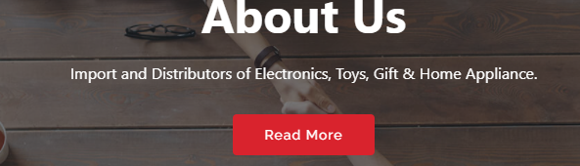

Importers and Distributors of Electronics, Toys, Gifts and Home Appliances

**SERVICES**

Imported items are ordered from manufacturers who have been in business for decades, therefore we can purchase high quality products at reasonable prices. It can continuously meet consumer demand. This division has a distribution unit with 25 lorries and over 65 employees for island wide distribution.

#### RESPONSIVENESS

Upon a customer request, we guarantee super speed request-attending because we know how important it is to have what you desire to be provided to you in a hastily manner.

#### CREDIBILITY

Finally, we are constantly striving to be a company/business partner that our customers can fully rely on with their time and money thus having a strong assurance and confidence of the quality of the products and services provided to our valued customers by us.

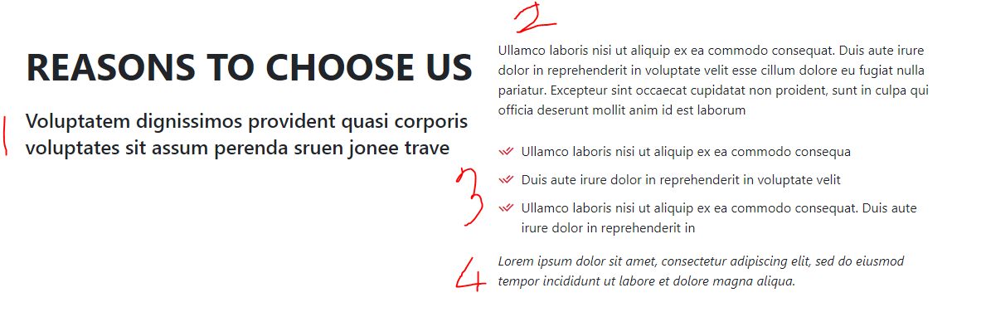

1. We are one of the leading companies in the country when it comes to providing high quality products at reasonable prices for our valued customers
2. Our business was started in 1995 and since then we have managed to achieve some important milestones while constantly keeping the trust our consumers have put on us by providing them with the paramount. We always strive to hastily attend to our customer’s needs and wants. At Ran Holdings we are willing to walk that extra mile to exceed our beloved customers’ expectations. It is not only about being the providers of high quality products but also to make certain that our products are reached to customers at reasonable prices.
   1. Imported Electronics, Toys, Gifts and Home Appliances of the highest quality
   2. Reasonable prices
   3. Excellent customer service
   4. Island-wide distribution
3. Don’t hesitate to reach us for all your electronics, gifts, toys & home appliances need at Ran Holdings. Be our customer today and see the difference for yourself